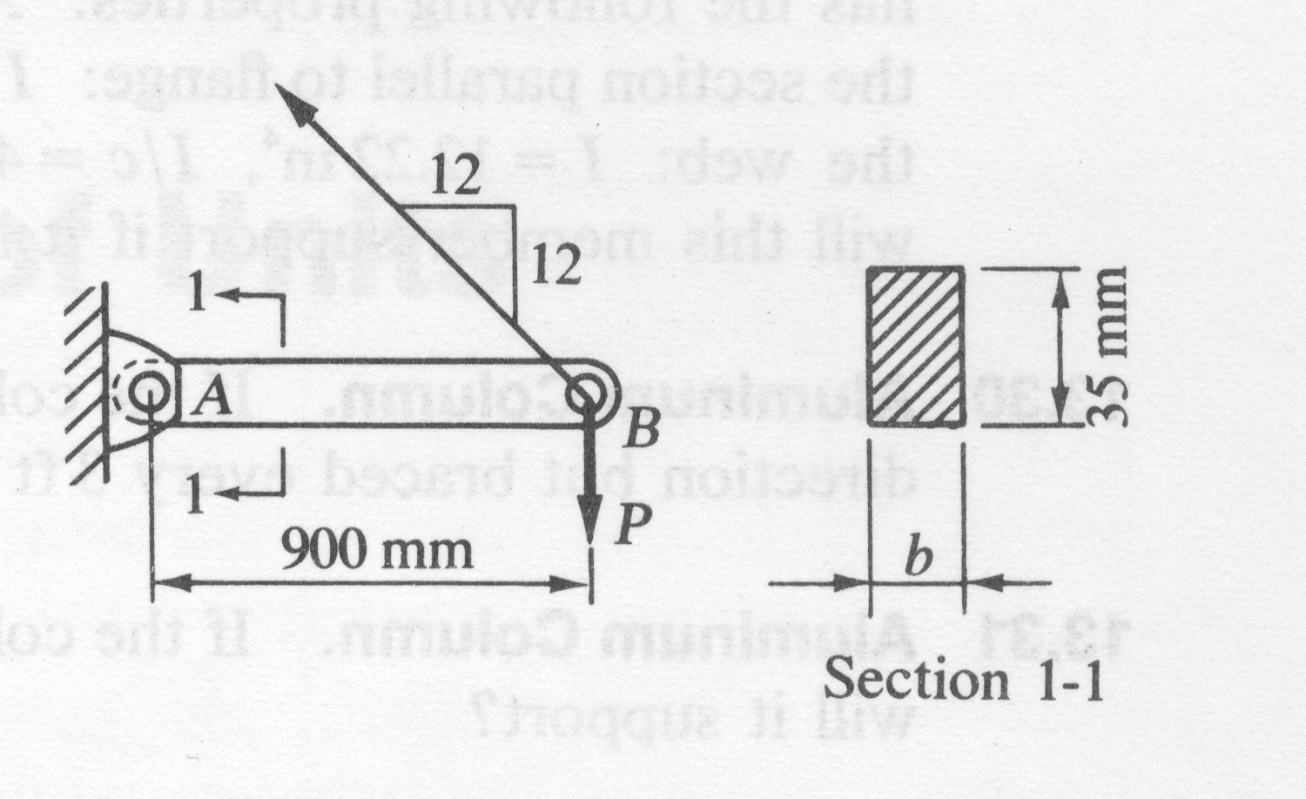
Prob 14: The small jib crane is made so that at point A, the connection to the wall, the pin permits vertical rotation, but has sufficient restraint sideways so that member AB can be considered fixed in the direction normal to the plane of the page at that end. End B of member AB is free of the out-of-plane restraint. Thus in the plane of the page there is a compression member pinned at both ends, and in the direction normal to the plane of the page a compression member fixed at one end and pinned at the other.

(a) If the height of the member is 35mm, what should its width “b” be to have equal probability of buckling in the two perpendicular directions? Use Euler’s formula with a factor of safety of 2. The material is aluminum whose E is 70GN/m².

(b) what load P can be supported at point B?

